
Trap Neuter Vaccinate Return Maintain (TNVRM)

How to Help Community Cats

TNVRM is a comprehensive management strategy for humanely reducing populations of free roaming felines in our community.

TNVRM includes 1) assessment of colonies
2) humane trapping
3) maintenance with food, water, shelter & medical
4) monitoring to assure newcomers are fixed

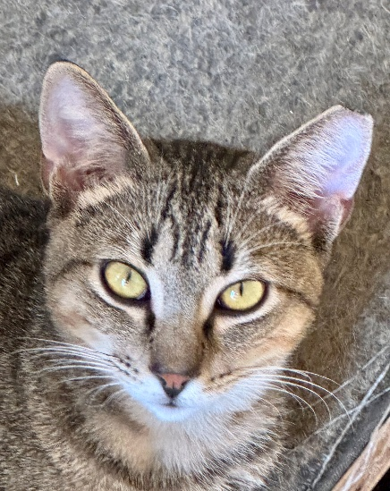

What We Do
- Help community cats by training caregivers on TNVRM (Trap Neuter Vaccinate Return Maintain) and assist properties to properly manage their colonies
- Provide TNVRM assistance, when possible, through our staff & volunteers.
- Reduce cat euthanasia in our shelter
- Reduce the community cat population by attrition

What are Community Cats?
Community cats live outside. While they may be friendly to one or two special people who care for them, most people cannot pick them up or touch them. Therefore, they are not friendly enough to be adopted through an animal shelter and should not be brought to the shelter. Even the friendly ones are better off where they are under the supervision of a caretaker.

Community cats are "home" where they are right now. There is nowhere better to send them and you cannot “relocate” them with other colonies as cats are territorial and they will not be accepted. TNVRM is their best chance at a healthy and happy life. Removing them doesn’t work since others will move into the vacant area. A 100% spayed and neutered colony will keep others away and in turn the colony will keep your area rodent free! Fpr emergency situations when cats lives maybe in danger contact us for possible solutions.

What is Trap Neuter Vaccinate Return Maintain (TNVRM)?
Trap: Humanely and painlessly catch cats using special traps.
Neuter: Sterilize cats to prevent future kittens from being born.* (And more! See below)
Vaccinate: Cats are given protection from diseases and improves their health
Return: Return cats to their original outdoor home.
Maintain: Provide food, shelter and monitor colonies long term.

TNVRM has been around for decades and is used internationally to control both dog and cat populations safely and humanely.

How does TNVRM Help Cats & the Community?
- No new litters of kittens. Stabilizes population size and reduces numbers over time.
- Sterilized cats are evaluated by a veterinarian and only the healthy ones are released back.
- Sterilized cats don't spray, howl, and fight, so they become welcome neighbors.

This manual will help you learn how to:
- Use a humane cat trap
- Trap & Transport cats to the vet (when & where)
- Release cats back
- Keep cats & your community
happy and healthy

Table of Contents

TNVRM Colony Log 4

Trapping Supplies Checklist 5

The Cat Trap 6

Preparing to Trap 7

Trapping 8

Community Spay/Neuter 9

Returning Cats 10

Caring for Cats 11

Frequently Asked Questions 12, 13

TNVRM Colony Log Model

Location: __________________________________________

Cat Name | Description | M/F | S/N Date | Revolution | Notes
8-Ball | Black, short-hair, chubby | M | 4/6/2015 |  | Old injury right eye. Healed fine.
Mama Cat | Calico, long-hair | F | 4/6/2018 |  | Had 4 kittens, before being spayed

Trapping Supplies Checklist

Trap-related supplies:
- Trap
- Trap cover (old lightweight towel, sheet,) that will cover trap completely
- Newspaper to line trap, lightweight cardboard or an old pillow case
- Flashlight (if trapping at night)

Bait supplies:
- Bait (tuna in oil, fried chicken, or other smelly food)
- Fork / Spoon to scoop out bait
- Can opener (or put bait in sealed container beforehand)
- Paper bowl or plate, if using (you can put bait directly on newspaper too)
- Wet wipes or paper towels for your hands
- Plastic bag for trash

Holding area supplies:
- Tarp, old shower curtain liner, or trash bags to protect the ground
- Newspaper to absorb moisture

Transport supplies:
- Tarp, old shower curtain liner, or trash bags to protect car
- Newspaper to absorb moisture
The Cat Trap

Humane cat traps have a front door which is propped open. The cat walks in to eat some tempting food, steps on a "trip plate," which makes the door shut behind them.
Some traps have double doors which can both be open for more difficult to catch cats.
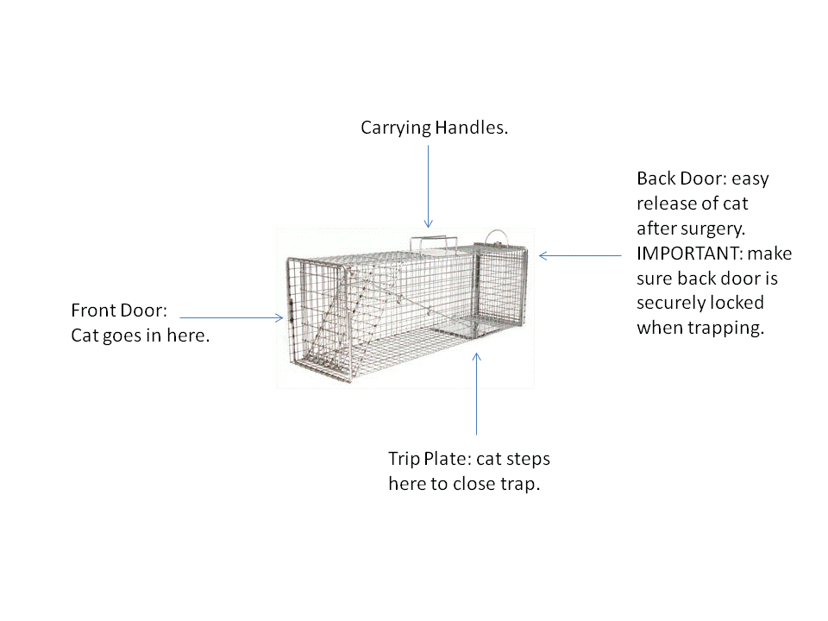
This picture shows a volunteer releasing a cat using the back door, which raises up completely.  Note the trap is covered. Always keep a trap covered (with a sheet or light weight towel) when there is a cat inside.  This calms the cat and makes everything less stressful for everybody.  DO NOT TRANSPORT a feral cat in anything other than a trap!  NEVER Transport a carrier or trap in the trunk of the car! | 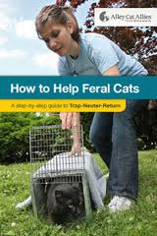
Photo courtesy of Alley Cat Allies
Preparing to Trap

- Start a TNVRM Colony Log, listing each cat you see at your location.
- Establish a regular feeding schedule for the cats.

- Feed in the area you plan to trap (quiet, sheltered, flat ground, out of public view).

- Prepare the holding area where cats will go once they're trapped and waiting to go to the vet. Cover the ground with a tarp or trash bags and a layer of newspaper. Holding area should be away from other animals.
Examples: garage, bathroom, porch etc.

- Prepare your car for cat transport. Cover seats with tarp, or trash bags and a layer of newspaper.

- Do not feed at least 12 hrs before trapping.

- Practice setting traps. If trap has a back door, double-check that it is locked. Secure it with a cable tie, if necessary.

- Check the weather: very rainy days or very windy days are less likely to be successful.

Trapping

Set the Stage
Feed the cats at the same time every day. This location should be quiet and out of public view. The trap needs to be on flat ground to work.

Trapping
Trap the night before or the morning before your appointment. NEVER trap on a weekend if you did not confirm first that the clinic is open or during the week without knowing that you have an appointment!!
The best time to trap is when the cats gather to be fed. Trap only when you can supervise.
Never leave traps set and unattended.

- If you have a trap with a back that closes check that the trap’s back door is locked. You may need to secure it with a cable tie, or string. Cats can and do escape out the back door if it's not properly locked.
- Put a trail of smelly food or roasted chicken from the trap front door to the back of the trap. Setting the food right on the newspaper or cardboard you have lining the bottom is fine. Don't put a can in the trap, but use a paper or styrofoam low bowl. Most of the food should go way in the back, behind the trip plate.
- Set the trap. TEST IT. Cover the trap ½ way. Leave the area but keep watching the trap.

- When you've caught a cat, keep the trap covered. It is normal for the cat to move around in the trap. Carry the trap to your holding area. If you need to trap several cats, put out several traps. When the first trap trips, the other cats may run off, but they should return. Just remove the cats as they are trapped and put them in the safety of your holding area.
Don’t open traps for any reason! Don’t try to transfer the cat
into something else! Don't keep looking under the trap cover at the cat -- you are only stressing them out!
Release the cat if the ear is notched!
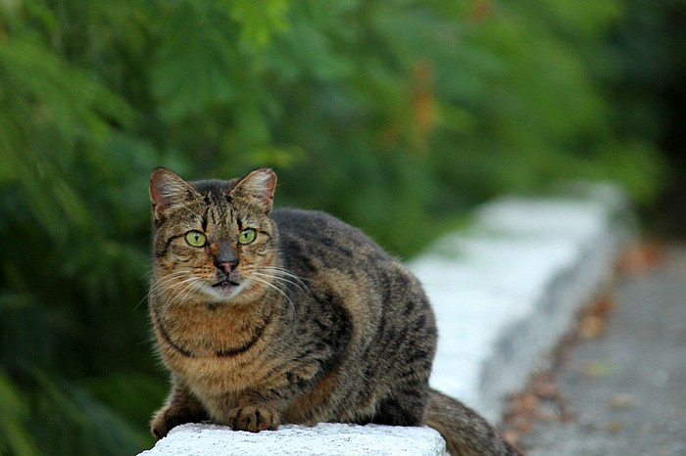
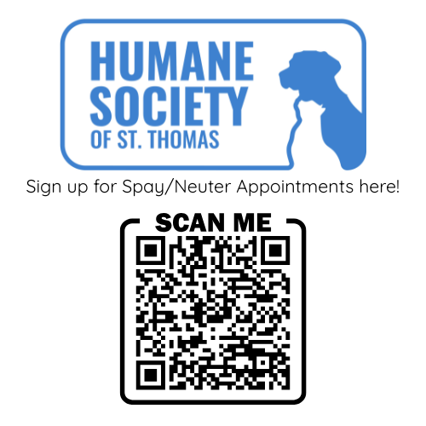
Location: Humane Society of St. Thomas 4012 New Herrnhut Charlotte Amalie, St Thomas 00802

Call or Text Community Outreach Programs Manager at: 340 203-0555 during business hours 10:00AM -4:00PM and prior to setting traps if you have any additional questions.

Community cat caretakers and pet owners in need of financial assistance can have their cats spayed and neutered through our HSSTT’s Government assisted S/N Fund and Spay a Stray Angel Fund FREE of charge

Although low cost or FREE (included spay or neuter, deworming, vaccination, parasite control, ear tip, and pain medication) the caretakers of these colonies are asked to provide basic care to the colonies they manage long term: food, water, medical care when needed and shelter.
An ear tip is mandatory for all outdoor, free roaming cats. An ear tip is the surgical removal (while under anesthesia) of the top 1 cm of the left ear. The ear tip enables the cat to be easily identified from afar as an already altered cat.

Cats brought in on Community Cat S/N Day must be in humane wire traps. If you need traps you may rent them in advance from HSSTT for a refundable deposit. Please have your trap covered with a lightweight towel or a sheet. Please note that a $25 fee will be charged if the cat is brought in a carrier.
___________________________________________________________

Note:
Our clinics operate under the direction of our shelter Veterinarian Dr. Tracy Williams and with the volunteer assistance of HQHV stateside veterinarians.

We are in need of help: air miles, accommodations, transportation, lunches, volunteers and more!
For more information call S/N Committee Chair at: 340 513-1854.

Returning Cats
Cats are ready to be released once you pick them up. If still groggy let them stay in the trap until fully awake. Keep the trap covered. When they are fully awake release them as soon as possible. This is particularly important for mother cats with kittens.
When you release the cats, they will run out and seek a hiding spot. Knowing this, you should place the trap near a preferred hiding spot and so that they will not run into harm's way (traffic).
Choose a quiet moment when there isn't a lot of commotion around to release cats.
- Carry cat in the trap back to the location where you trapped him or her.

- Set trap on the ground.
- Point trap in the direction you want the cat to run. Give them a clear escape route.
- Remember the cat wants to run away from you, so stand behind the trap, not in front.
Cats will be hungry and thirsty. Make sure fresh water is available and be generous with the food. It is normal for cats to hide for a day or two after trapping. Continue to feed as normal.
Within a few days, everybody will be back to business as usual!

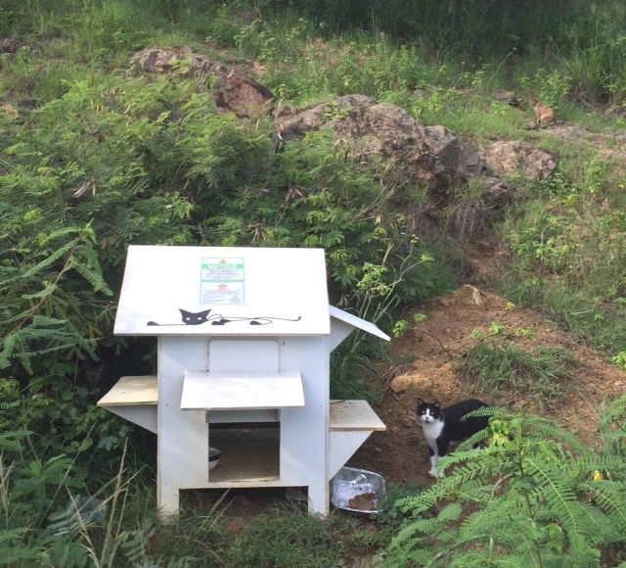

Caring for Cats
Food and Water

Cats need food and water every day. Properly fed colony cats will have access to dry food and ½ can each daily as well as access to clean water at all times. Can food is especially recommended for areas which are in close proximity to restaurants in order to keep the cats away (mostly on resort properties)

For feeding information for your cat or community cats – Basics of Feline Nutrition this is an excellent source of information: catinfo.org

Shelter

Cats can do well if they are healthy, well-fed, and have access to shelter.
A good shelter stays dry and is out of the wind and rain. Make sure the area is kept clean.
You can build great shelters using storage bins, ice chests, and other affordable items.
There are also many great ideas online!

Additional Resources

Very good general information about caring for community cats: http://www.alleycat.org/page.aspx?pid=293

Keeping Cats Out of Gardens and Yards (neighborhoodcats.org)
- Rethinking the Animal Shelter's Role in Free-Roaming Cat Management
- Best Friends Community Cat Resources
- Best Friends Community Cat Programs Handbook
- Million Cat Challenge Pathway Planning for Cats
- Million Cat Challenge - The Cat Superhighway webinar
- Team Shelter USA - Community Cat Programs Handout
- Managing Community Cats: A Guide for Municipal Leaders
- How to Trap a Feral Cat for TNR
Newcomers
Outdoor cats can survive years in a managed colony. When all the cats in the colony are spayed/neutered, and ear tipped, your colony will be under control. Watch for any new cats.
You should be able to identify a new cat as it will not be ear tipped and will not be documented on your TNVRM Colony Log.
Frequently Asked Questions
What about Pregnant Cats? Females with kittens?
If you have a cat that you think is pregnant, the cat can be spayed.
What this means is the cat will have surgery and the kittens will be aborted
If you have a mom cat out there with little babies already born, we need to make sure the kittens are old enough to eat on their own before we take mom away for surgery.
After mom has surgery, it will be uncomfortable and painful for her to nurse the kittens. Most kittens can start eating on their own around 5-6 weeks. This is also the time that they become more mobile. If the cats are out in the open, they are probably close to this age. If the kittens are big enough that they are running away from you and are difficult to catch, they are probably closer to 8 weeks. If you don’t think the kittens are old enough, and you can continue to watch mom and babies, it is best to leave mom alone for a few more weeks. Note on a calendar when you’ve seen the kittens so you can keep track. Don’t follow mom too closely. She will get spooked and move the kittens. Instead, watch from afar to see which area she is going to. You will see the kittens as they get older coming out into the open.
This will be the time that you will need to start trapping mom and catching the kittens so that they can go into foster care for socialization.
When is a Kitten Old Enough for Spay/Neuter Surgery?
Kittens are ready for surgery when they are 2 pounds in weight (8-10 weeks of age). Rules of thumb: if they are faster than you they are about 6-7 weeks old.
Mom usually brings kittens to start eating food at about 7-8 weeks of age. So if you’ve been seeing kittens out and about, eating food, for a few weeks – they’re old enough for surgery.
If you have caught feral kittens when they are quite young (the younger the better, best is about 4 weeks of age while their eyes are still blue), and raised them in your home so they love all people, including strangers – congratulations! They are now tame kitties and can be placed in loving homes after 8 weeks of age. We always recommend that kittens are adopted in pairs and if you can foster them in your home we can advertise and help you place them. The animal shelter is usually full and are always in need of foster homes as well so please do your best to help prevent new litters and take great care in making sure that the kittens you adopt out to friends or relatives are indeed spayed and neutered first.
What about Difficult to Catch Cats?
There are often cats that are difficult to catch, whether it’s the smart one who avoids the trap or just the last one who manages to evade the trapping process.
If you get to this point, we will help guide you through the trapping process.

What about the Unfriendly Cats?
Most truly feral cats will keep their distance from humans. These cats are similar to wild animals. They can’t be touched or picked up to pet. These cats do not enjoy human company and are not suitable for adoption. Some feral cats may come close to you and even allow you to pet them while they are eating. Although these cats have developed a tolerance of their human caretaker enough to allow these actions, chances are that a new human could not do the same things to the cat. These semi-feral cats are accepting of their caretaker but that is where it stops. These cats will also not be suitable for adoption centers because once out of their environment, they will act much more like the true, wild, unsocialized cats.
Again, they are best left where they are. Once fixed, these cats will live a happy life and their behavior will no longer be a nuisance (males will stop spraying, yowling and fighting and females will no longer reproduce and increase the colony population)
Thank you for caring! Working together we can stop the vicious cycle of homelessness…
One stray at a time.

